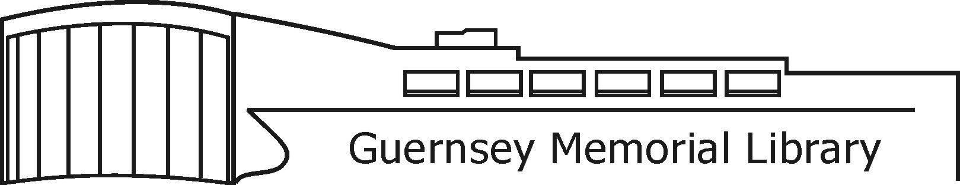
3 Court Street, Norwich, NY 13815 Phone (607) 334-4034 Fax (607) 336-3901 guernseymemoriallibrary.org

«Name»
«Street»
«City» «State» «Zip»

October 1, 2018

Dear Chenango County Neighbor:

I am writing because the library is beginning work on a project we believe could benefit from your expertise as a leader in the Norwich/Chenango County community – our 2019 – 2023 Strategic Plan.

The library traditionally provides information in a variety of formats – books, DVDs, electronic, and interpersonal - for the enlightenment, inspiration, and entertainment of the community. But we believe strongly that the library should be a dynamic organization, responsive to the needs and concerns of the community it serves. As a step toward better understanding local needs, and configuring our future services to them, we are inviting you to participate in one of our community conversations.

These community conversations will be similar to focus groups, but less structured and formal. We plan to provide light refreshments, have brief introductions around the table, then open the conversation by asking participants to share what they think are the major challenges and opportunities facing their friends and neighbors in Norwich. Preliminary investigations have yielded issues like food insecurity, homelessness, income inequality, and literacy. We expect we will have some interesting discussions, come up with ideas about what could be done about some issues, and perhaps even to forging new relationships between different individuals and organizations in the community.

After the conversations are concluded, we will summarize what we learn and share this information with participants and the community at large. We will also take these findings and try to figures out ways to address the issues, both as a library, and in partnership with other organizations in Norwich.

We would greatly appreciate it if you could RSVP to no.connie@4cls.org or 334-4034 if you can to attend one of the following scheduled conversations:

Sunday, October 21, 2 PM
Monday, October 22, 10 AM
Monday, October 22, 6 PM
Friday, October 26, Noon

Thank you so much for your consideration. We look forward to talking with you!

Sincerely,

Connie Dalrymple, GML Director
Community
Conversations

Interested in sharing in a conversation about the challenges and opportunities facing Norwich and the rest of Chenango County today? Please join us for one of our upcoming community conversations:

Refreshments will be provided!

Sunday, October 21, 2 PM
Monday, October 22, 10 AM
Monday, October 22, 6 PM
Friday, October 26, Noon

3 Court Street, Norwich, NY 13815 Phone (607) 334-4034 Fax (607) 336-3901 guernseymemoriallibrary.org

Guernsey Library Wants to Talk About the Future
Not only is Guernsey Memorial Library undertaking an exciting renovation project to update its bathrooms and increase building accessibility, but it is also looking to update and improve its other services to Norwich through community conversations and an updated strategic plan.
“The Library has always had a strategic plan,” says director Connie Dalrymple, “the difference this time is that we as we update our plan for the next five years, we are going to be using a “turning outward” approach, based loosely on an American Library Association initiative. The approach emphasizes taking steps to better understand the Norwich community; changing processes and thinking to make the library more community-focused; becoming more proactive to community issues and concerns; and putting Norwich community aspirations first. This approach is designed to help the library work with residents and community organizations to bring about positive change.”
To kick off the process, the library is soliciting input from the community via a wishing tree. Individuals with wishes for the Norwich community are invited to write their wish on a leaf and place that leaf on the wishing tree near the library’s front entrance. There have been many wishes so far, including wishes for housing and food for everyone, literacy for all, and for a spirit of friendship and cooperation between community members.

The wishing tree will be available for one more week. The next step will be a series of community conversations, to which the entire Norwich community is invited. There will be light refreshments, brief introductions, then a conversation opened by summarizing the wishes from the wishing tree and asking participants to share what they think are the major challenges and opportunities facing their friends and neighbors in Norwich.

“I expect we will have some interesting discussions, we’ll come up with ideas about what could be done about some issues, and perhaps some new relationships will be forged between different individuals and organizations in the community,” says Dalrymple. “After the conversations are concluded, we will summarize what we learn and share this information with participants and with the community at large. We will also take these findings and try to figure out ways to address the issues, both as a library, and in partnership with other organizations in Norwich.”

If you would like more information, email Dalrymple at no.connie@4cls.org or phone 334-4034. If you would like to participate in one or more of the planned community conversations, they will be held on the following dates:

Sunday, October 21, 2 PM
Monday, October 22, 10 AM
Monday, October 22, 6 PM
Friday, October 26, Noon

