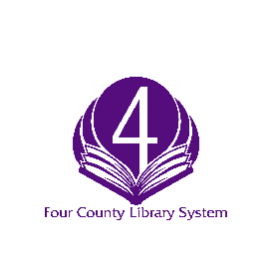
New York State Construction Aid Program
4CLS Notification of Intent to Apply Form 2020-2022
Due to Brian Lee at 4CLS by June 19, 2020
Director Name: ______________________________________________________________
Library: _____________________________________________________________________
Describe the project in one sentence: _____________________________________________
____________________________________________________________________________
Describe the project briefly but completely: _________________________________________
_____________________________________________________________________________
_____________________________________________________________________________
_____________________________________________________________________________
How will this project improve service to the community? _______________________________
______________________________________________________________________________
______________________________________________________________________________
If the project is funded, when will it begin (approximately)? __________ End? ____________
This year’s total cost of project: ____________________________________________________
Funding requested (up to 75% of cost for eligible libraries*): ____________________________
*See Reduced Match Eligibility Criteria
If awarded through the NYS Construction Aid Program, the library will begin the project within 180 days of notification of award from NYS.
_______________________ __________________________
Name of Library Director Name of Board President

________________________ ___________________________
Signature of Library Director Signature of Board President

For more information go to: https://intranet.4cls.org/?page_id=1102 or contact Brian Lee, blee@4cls.org

